Thornhill House Residents’ Association meeting notes.
Meeting date/time: 7.30pm 6th November 2013
Present: Penny, Colleen, James, Mike, Claudia, Andy, Brian, Bettina, Rita, Anu, Kaz
Apologies: Lee McDermott (LBI) – double booked
Item | Key points discussed | Action Required | Lead
Review previous minutes | Re. Bike Shed – some bikes have been in there for years and it’s hard to know whose is whose. Betty has email addresses of some leaseholders and will forward to the RA. Question via Andy – a resident with a double bugy would like to use the bike shed occasionally and is happy to pay. Agreement that this is fine.  No responses re. gardening consultation.  Vermin - a neighbour has told Kaz he’s seen a mouse in his flat. James has seen another rat in the bushes outside the 1-15 end. | Residents reminded to contact pest control on if they see anything  List of leaseholders’ email addresses sent to James | All  Bettina
Further discussion of TH storage room usage – THRA to pursue safe/fair use through the council/Lee | Question from Kaz – is there a difference between Leaseholder and Tenant rights? Is there a difference in rights to storage dependent on the size of the flat. Penny has been told that previous Chair has the previous storage audit. Brian has previously been told he would be “put on a list” for storage, but didn’t end up with anything.  Penny reviewed the current situation re disparity between different residents’ use of storage. A number of views expressed about the situation – who deserves what and who is entitled to what.  Clarification from LBI is needed before we can move forward on this issue. | Clarification to be sought from Lee about existing policy and residents’ rights regarding storage. | James
Dummy cameras | No action currently needed as doors have not been damaged since last repair job. Concerns raised about the quality of the repair work. | Residents concerned with the quality of the repair work should report the issues to LBI | All
Environmental improvement bid | Follow up next meeting when Lee McDermott available.
Community Room update – policy documents | Colleen showed the website to the committee – the bookings calendar. Explained the different charging bands for the CR. This is now published on the website.  Inventory needs to be taken. Some redecoration needed.  Colleen proposed book/DVDs swap shelf. Query when this could happen. Suggestion that the CR is opened on a Sunday afternoon etc for swaps.  Colleen asked for suggestions about social activities for the CR. Suggestions ranged from craft fairs to jumble sales, movie nights, coffee mornings etc.  Sunday night suggested for a horror movie night. – 8th December. | Penny, Claudia, Andy, Colleen to move some furniture around, put up shelves, inventory the CR etc. | Colleen
Christmas party | Saturday 21st. | Letter to go to residents | Penny
Website | Website is now live. Includes brief history, club info, community room bookings info, events, bike shed info and payment system, blog, forum, minutes of meetings, photos, useful links and contact form:  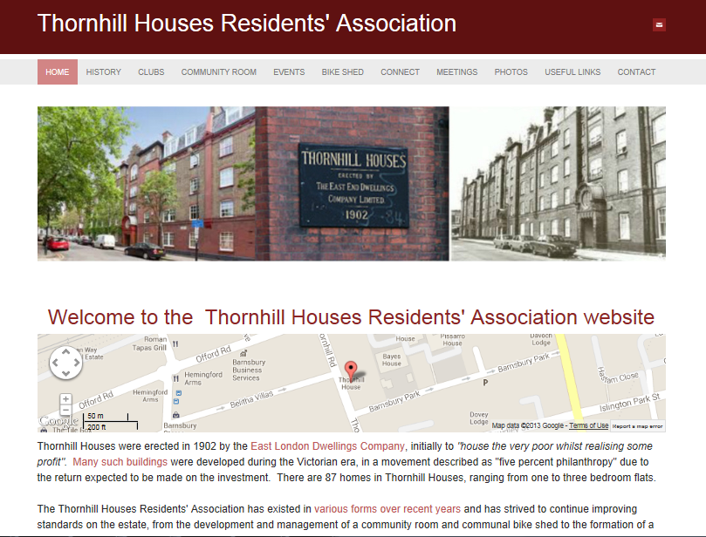  www.thornhillhousesra.com | Residents encouraged to visit the website and share ideas about events and issues affecting TH. | All
Bike Shed update | Lock has been changed, tags issued, payments received, some bikes still unclaimed. | Contact to be sought with absent leaseholders to ensure messages passed on. | James
Jumble Sale | After Christmas – bags to be distributed to residents to collect jumble. Where to leave it? Can be left in room opposite CR. Lock/door still damaged despite LBI promising to fix it. | Penny to install new lock herself. | Penny
Antisocial Behaviour | Lewd behaviour reported by a number of residents. Damage to plants. Alcohol cans left in garden. | Residents reminded to report antisocial behaviour (24/7) on (020 7527 7272) or visit http://www.islington.gov.uk/reportasb | All
Dead Ivy | Whole section of ivy has been cut at base and is now dead. Complaint needs to be raised. | Kier to be contacted re. ivy. | Anu
Next agenda and time | Weds 15th January 7.30pm  Lighting in garden needs to be addressed. Is it just switched off or is it broken?  Rest of agenda TBC – Please email items to thornhillhousesra@gmail.com by 8th Jan 2014. | Penny to report lighting to LBI  All residents to email items to thornhillhousesra@gmail.com  James and Penny to meet re agenda | Penny  All  James
AOB | Issues with cleaning continuing. Stairwells either not cleaned at all or corners and banisters left uncleaned.  Leaf-blowing has just piled up leaves and left them there to be redistributed when the wind blows.  Timing of stairwell lighting is wrong.  Bins being put our too early so residents having to go outside to leave rubbish.  Recycling not collected on Saturday morning. One resident currently letting the recycling collectors in every week. This is not sustainable. | RA to contact council about these issues | Penny

